**AMAZECARE**

Hospital Management System

NAME : Shreetharan ST

EMAIL: [shreests07@gmail.com](mailto:shreests07@gmail.com)

BATCH: Java+angular (batch2)

SUPERSET ID: 5347489

TRAINER: Thaneshwara M

DATE : 16.07.2025

**ABSTRACT**

**AmazeCare** is a full-stack **Hospital Management System** designed to streamline and digitize the day-to-day operations of a healthcare facility.

It provides secure, role-based access for **Admins**, **Doctors**, and **Patients**, allowing each user type to interact with the system according to their responsibilities.

The platform enables **appointment booking**, **patient record management**, **doctor assignment**, and **prescription tracking** through a clean and user-friendly interface.

The backend is built using **Spring Boot** with **JWT-based authentication**, while the frontend is developed using the latest **Angular framework**, ensuring smooth and secure communication between components.

**THE PROBLEM IT SOLVES**

**1) Saving Time**

The main problem we facing to goto the hospital is the waiting period. We not exactly know the doctor’s timinig.

So we spend full day in the hospital. But amazecare offers appointment booking to the patient. The patient can choose their doctors on their own with their preferred timing.

**2)Maintaining the Prescription**

The another issue is the patient have to keep their prescription sheet safer. For the second visit they need to bring their prescription sheet, so that doctor can easily diagnose them.But the patient may miss the prescription

But amazecare stores all the prescription, test recommended, diagnosis details of the patient safely.

**3) Easy to manage**

Maintaining the hospital is a big deal for the hospital management. But our amazecare takes half of the burden of the hospital management

**Tools & Technologies**

* **Frontend:** Angular 20, HTML, CSS, Bootstrap
* **Backend:** Spring Boot (Java 17)
* **Database:** MySQL
* **Authentication:** JWT (JSON Web Token)
* **Other Tools:** Postman, GitHub

**Features**

• Role-based login (Admin, Doctor, Patient)

• JWT-secured REST APIs

• Medical history & prescription tracking

• Stylish responsive frontend with Angular

• Custom exception handling & validations

• Real-time error messages and status responses

**API’s used (Swagger screenshots)**

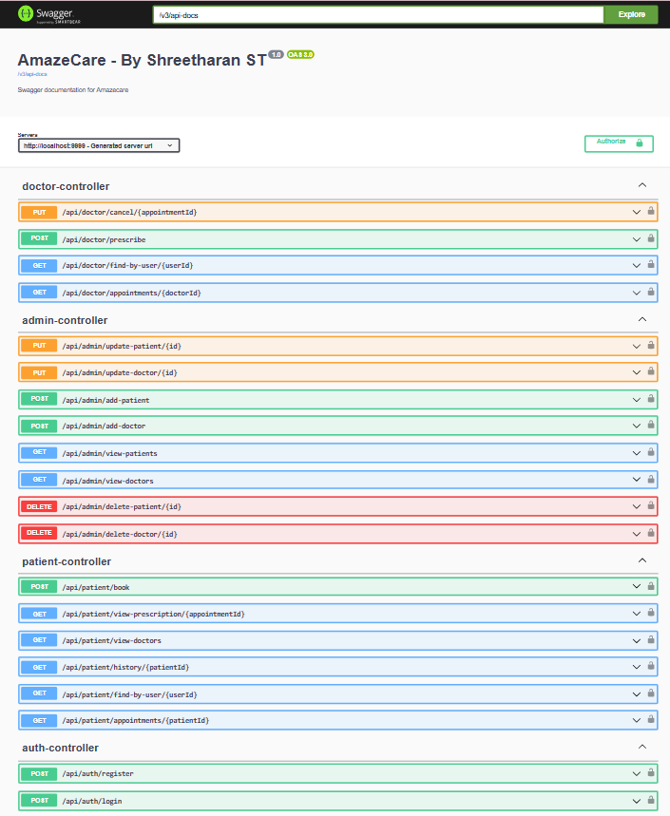

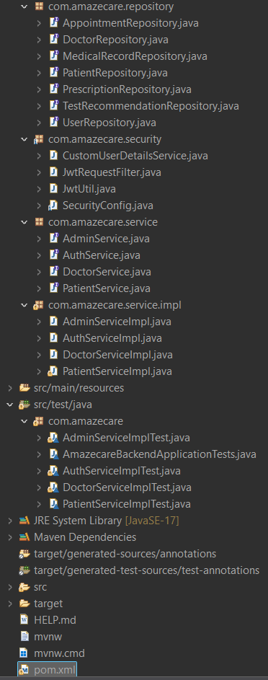**BACKEND FOLDER STRUCTURE**

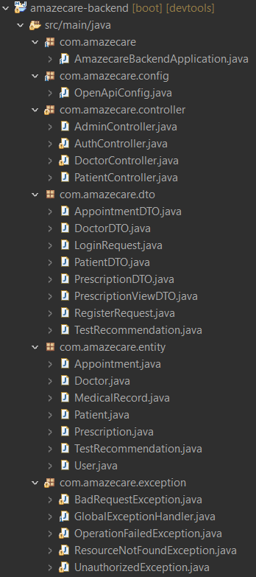

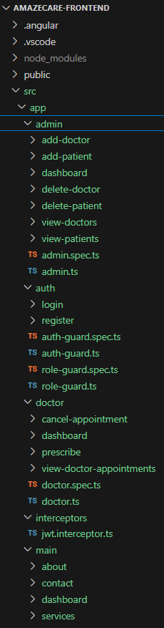**FRONTEND FOLDER STRUCTURE**

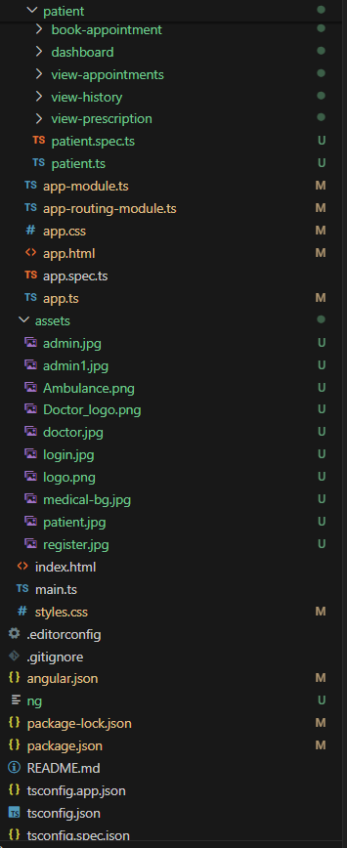

**DATABASE STRUCTURE**

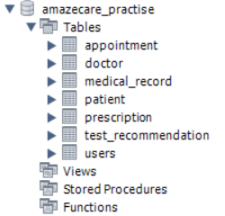

**MAIN-DASHBOARD**

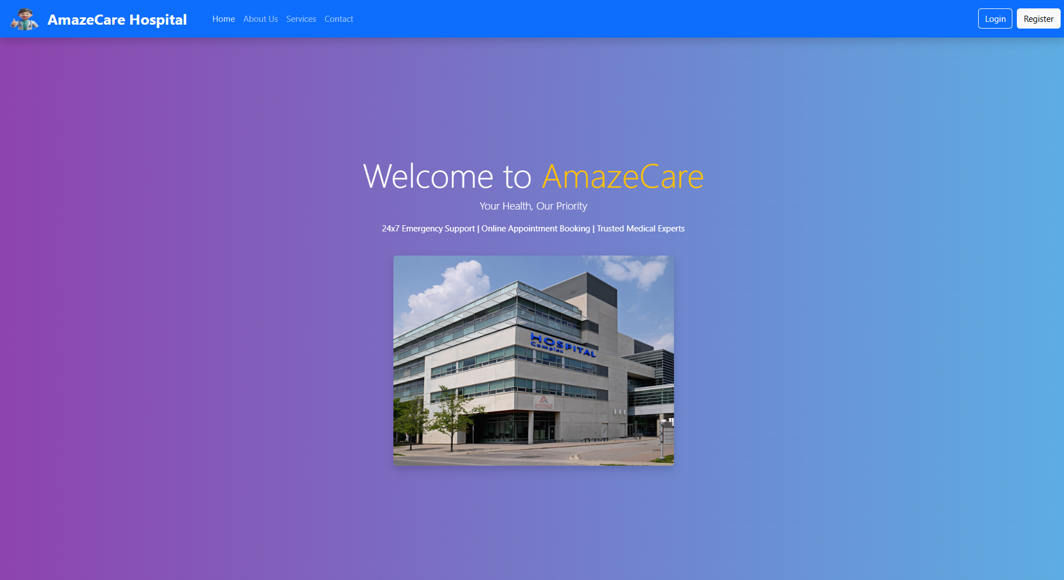

**REGISTER**

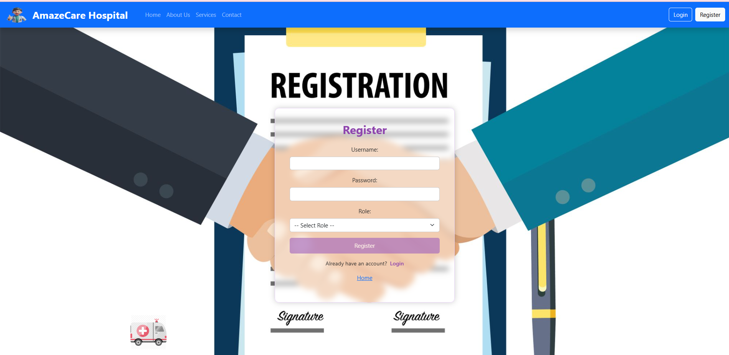

**LOGIN**

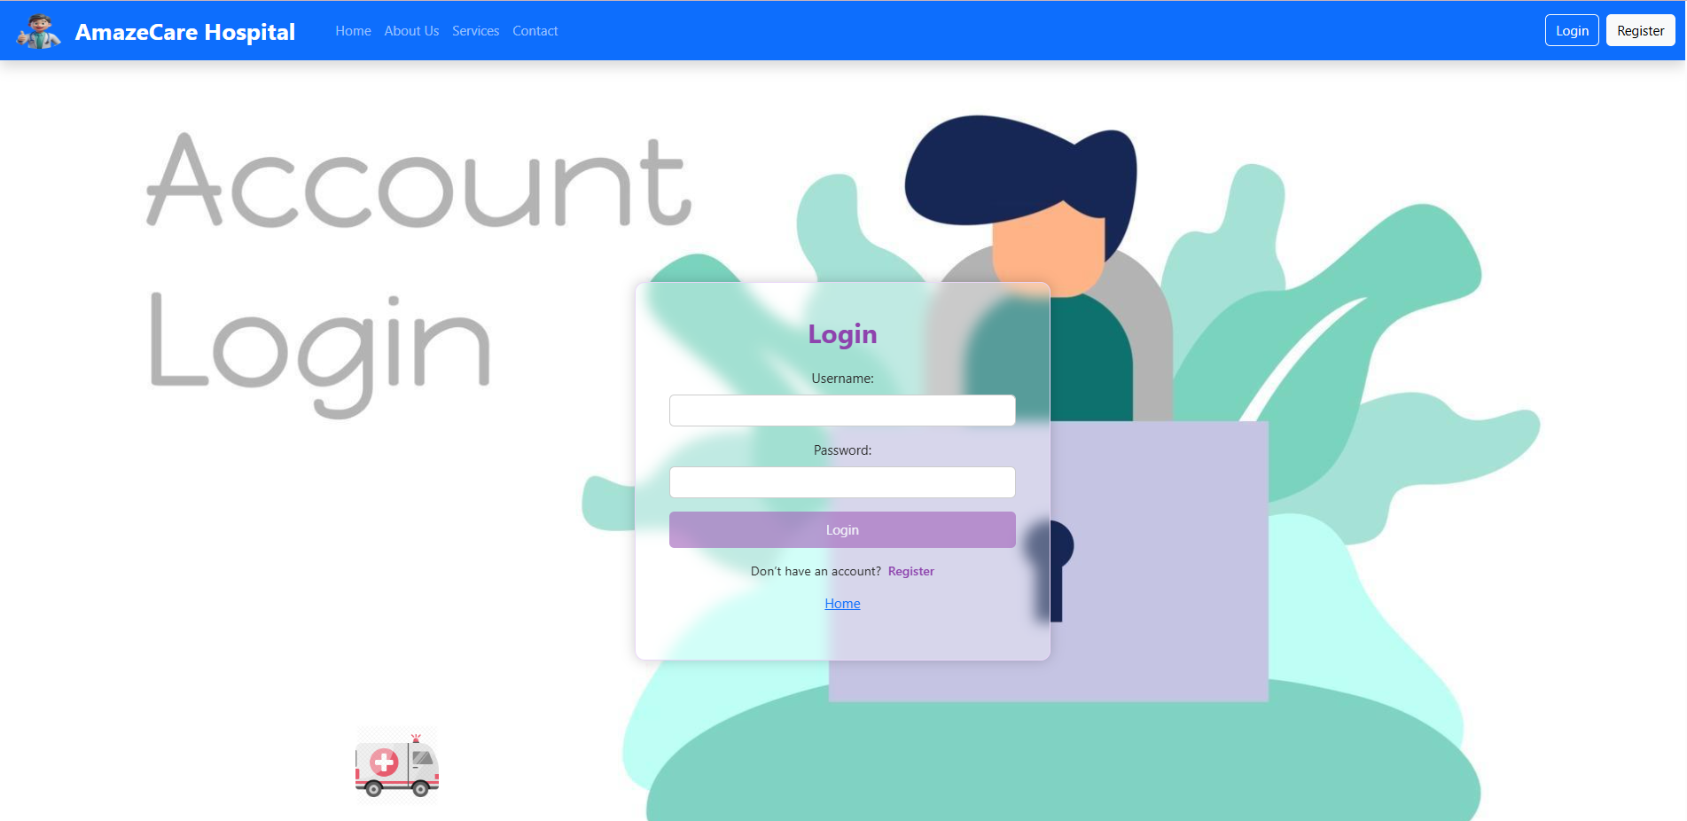

**REGISTERING AS PATIENT**

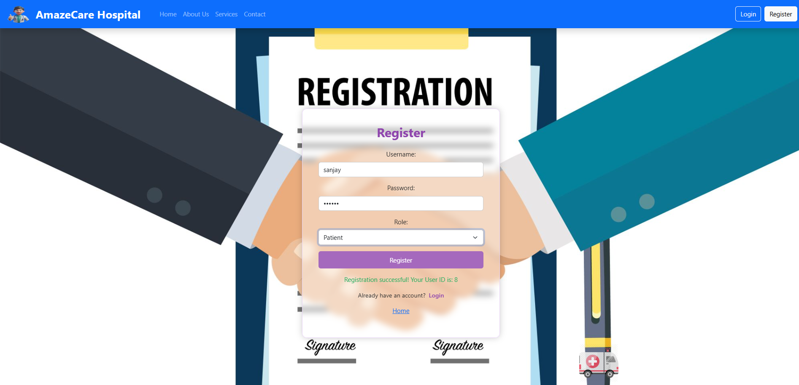

Now I am register user sanjay as a PATIENT.

After registering , I gives user ID is 8. The user has to keep the user id safe

**LOGIN AS ADMIN and ADD PATIENT**



Now I am login as admin. After login , the admin page opens

It is the **admin dashboard**

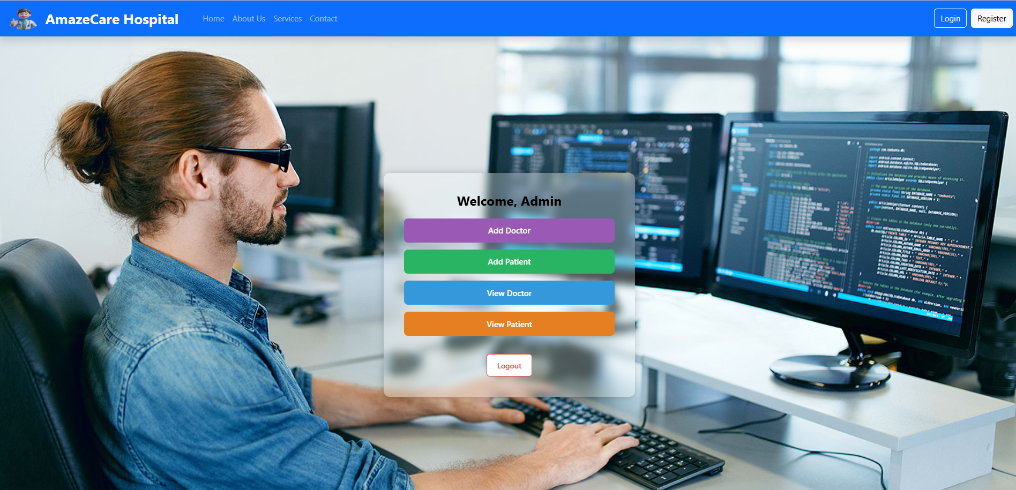

Now we are going to **add patient**

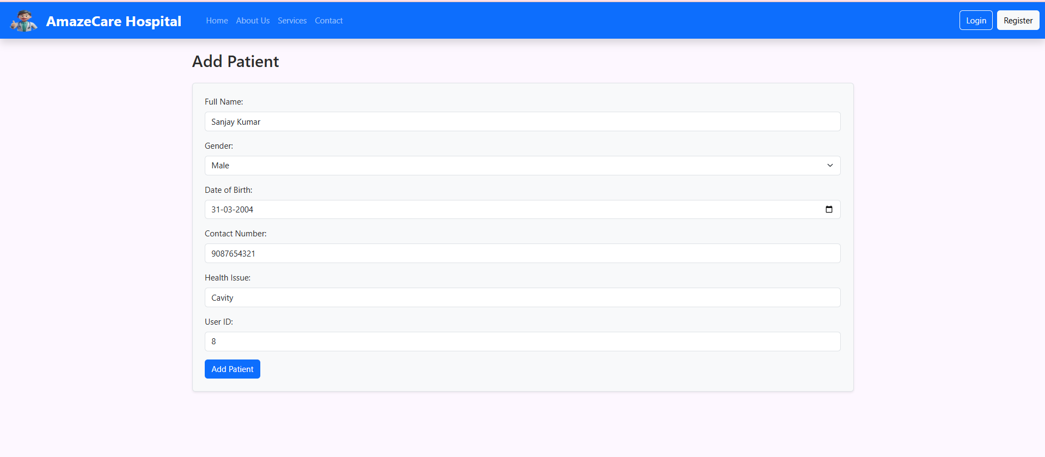

Using **View-patient – you can see Sanjay kumar is added**

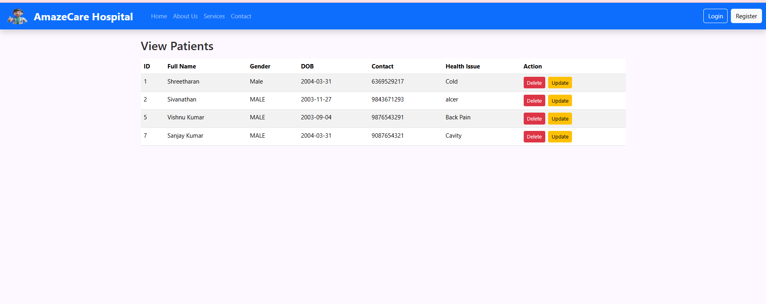

The below is patient table. Here you can see Sanjay Kumar is added successfully

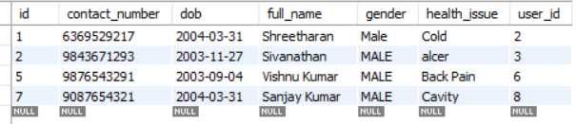

**REGISTER as DOCTOR**

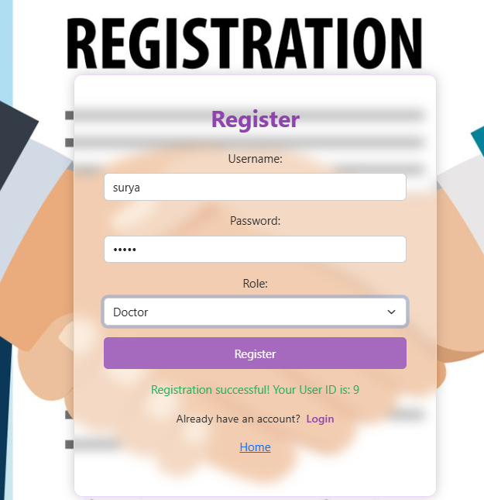

**Now again login as ADMIN and add DOCTOR**

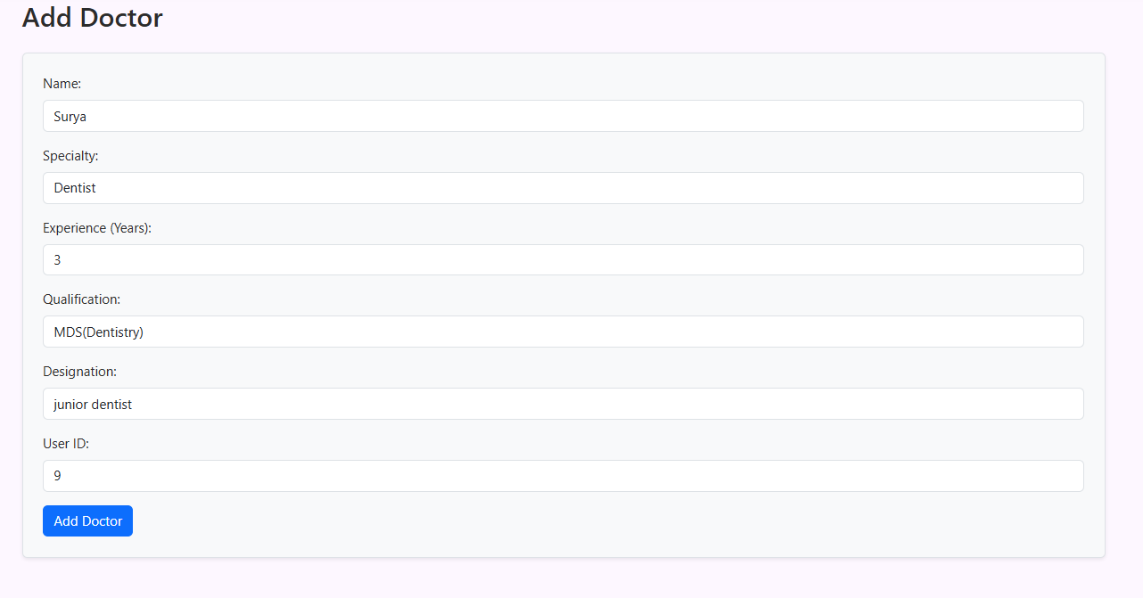

You can see in **view doctor** – doctor added successfully

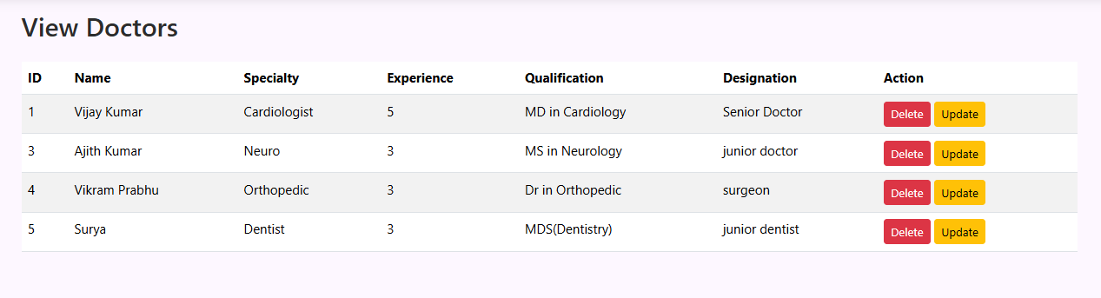

We can also able to Update or delete the doctor details as similar to Patient details

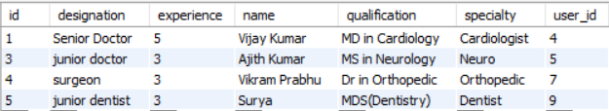

**LOGIN AS PATIENT**(SANJAY)

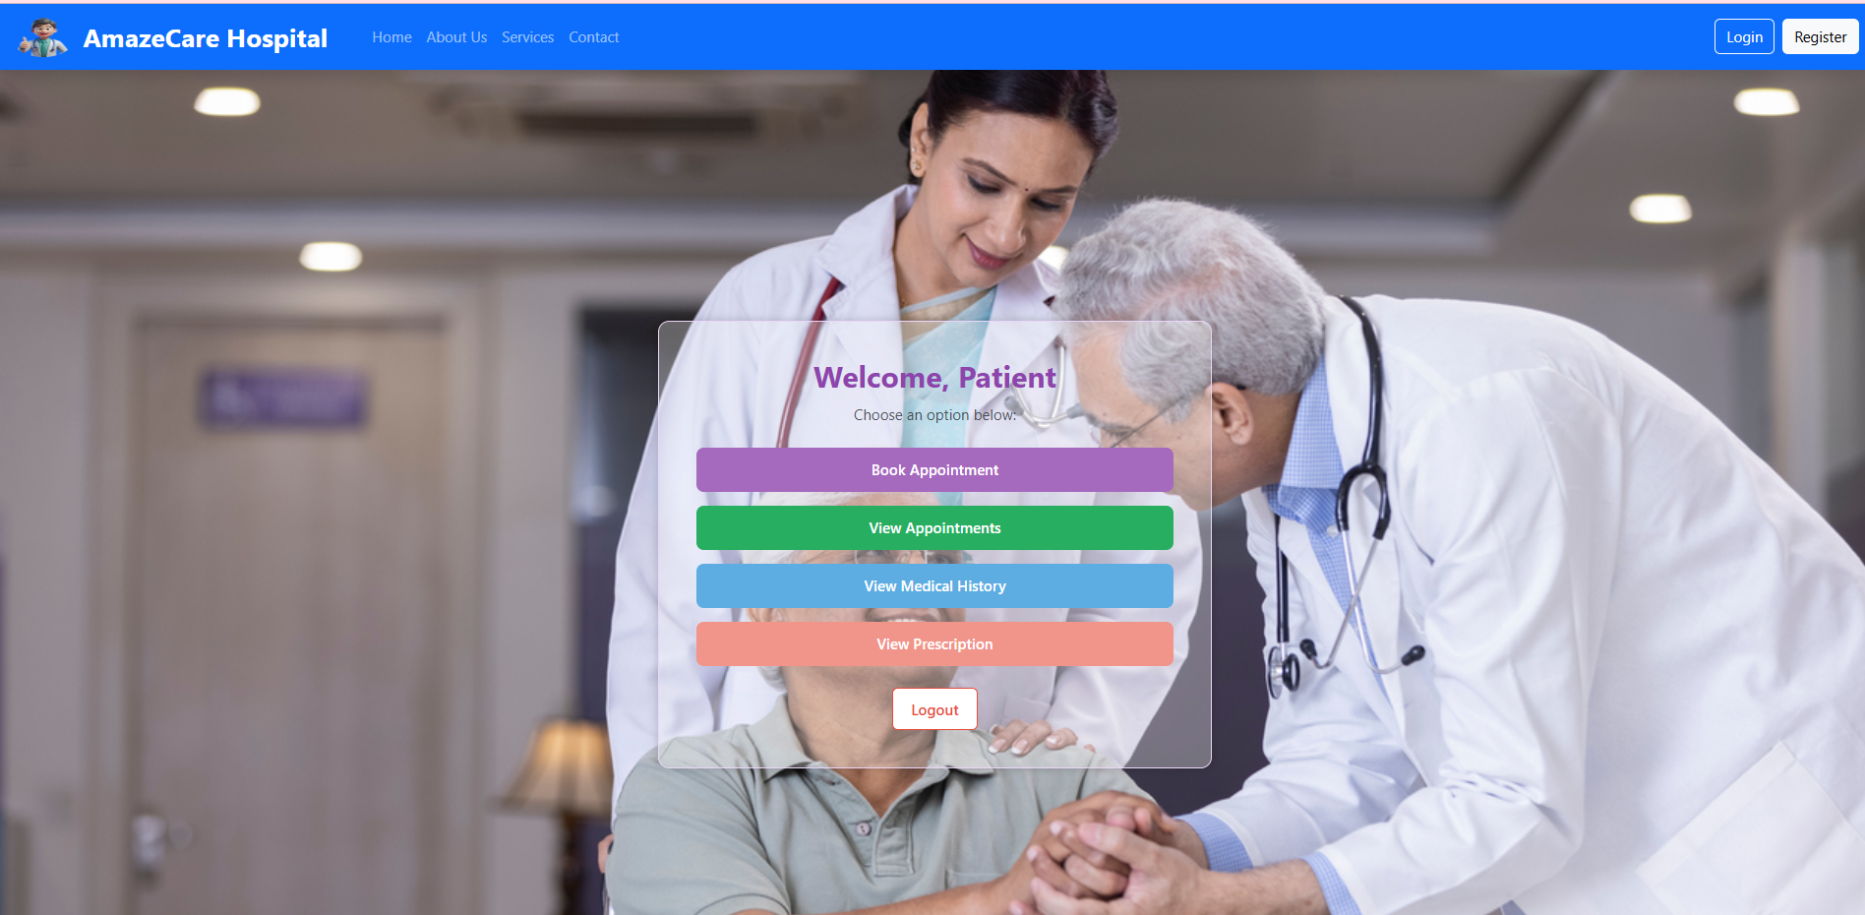

It is the Patient dashboard. I has 4 options to do by patient

**BOOK APPOINTMENT**

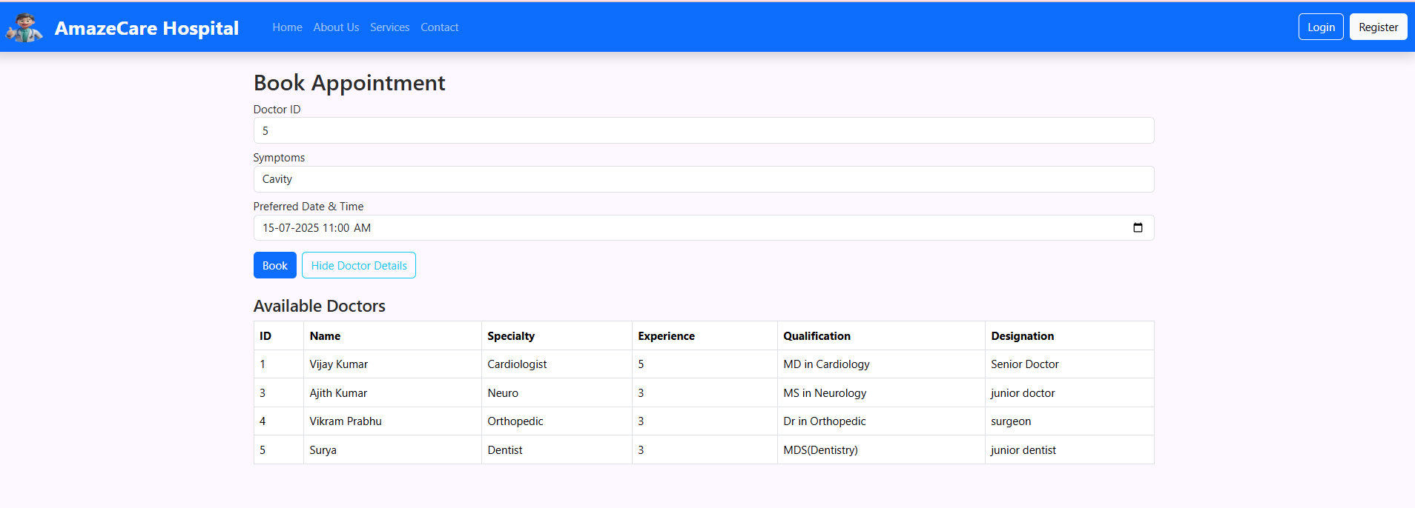

**VIEW APPOINTMENT**

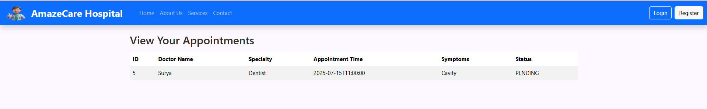

The **View Medical History** and **View Prescription** has some data when you attend the appointment(doctor). Currently It does not contains anything.Because it is a new patient.

**LOGIN AS DOCTOR**(SURYA)

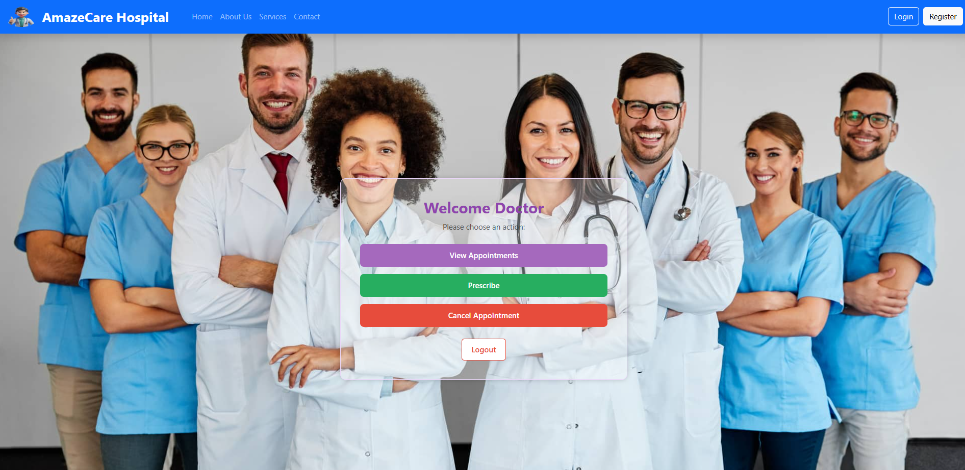

**VIEW APPOINTMENTS**

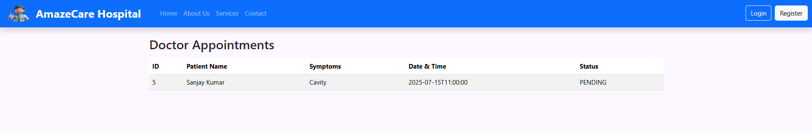

**PRESCRIBE**

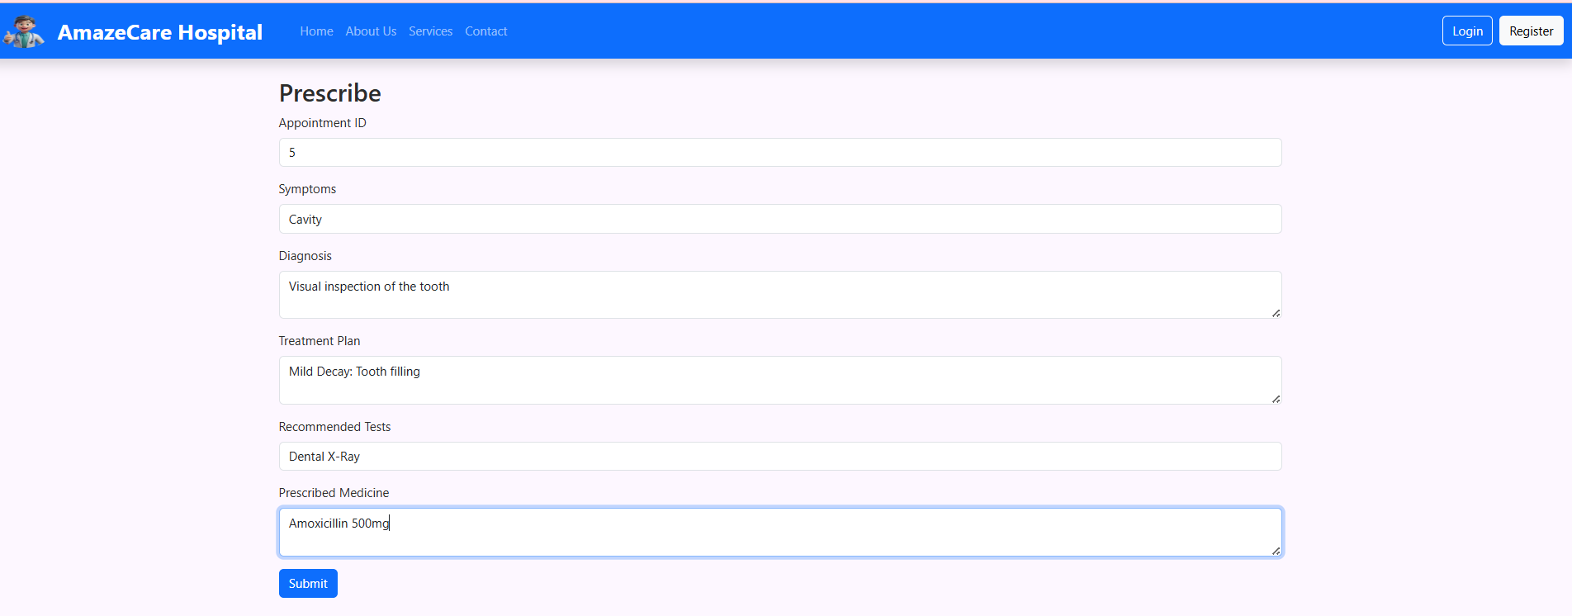

**CANCEL APPOINTMENT**

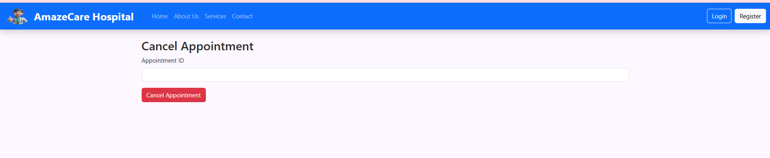

Now, LOGIN AGAIN AS **PATIENT(Sanjay)** , CHECK THE

**VIEW MEDICAL HISTORY**

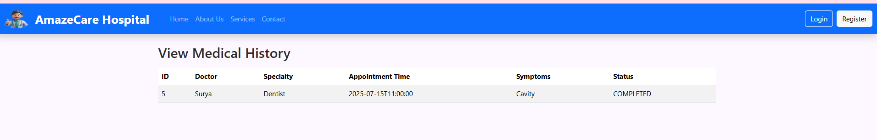

**VIEW PRESCRIPTION**

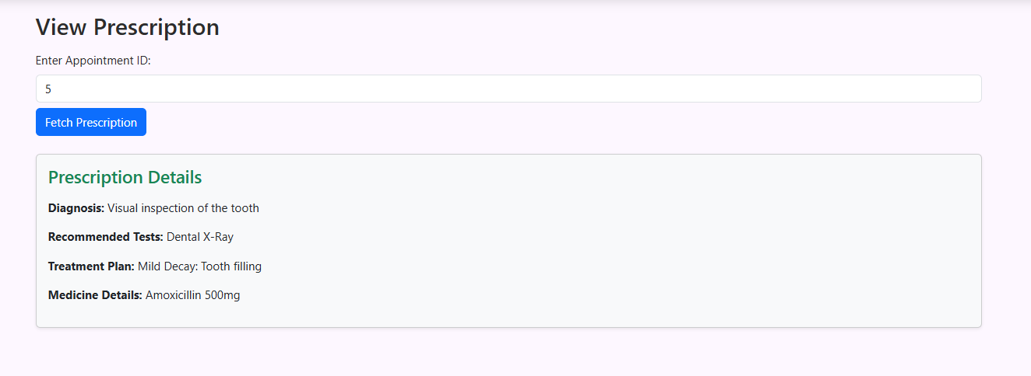

**The JWT tokens store in browser local storage**

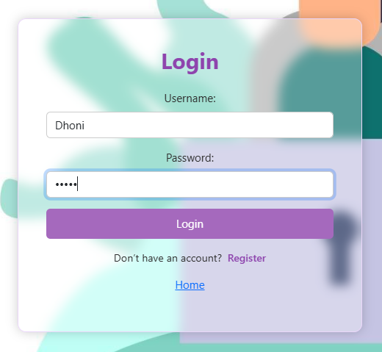

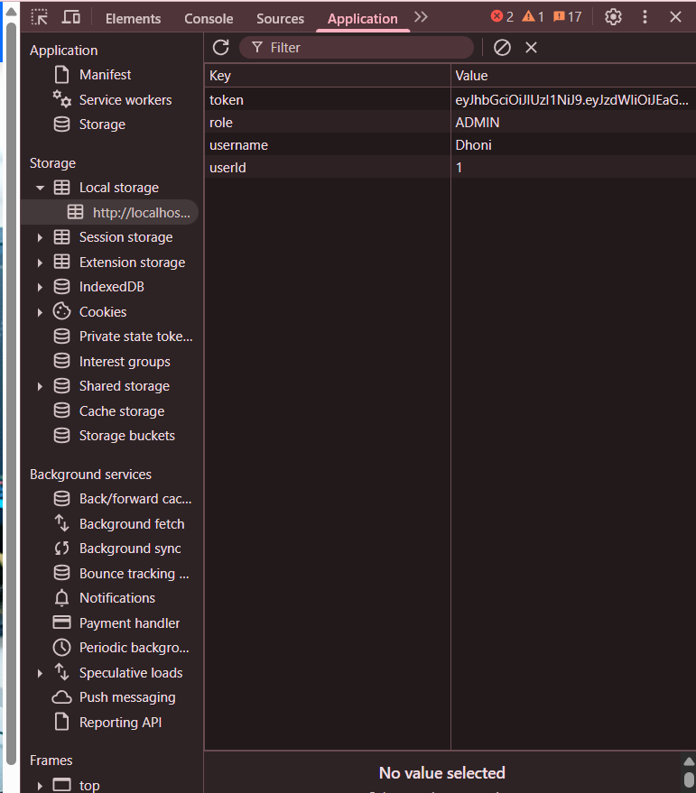

**VALIDATIONS**

I added validations, so that user can easily understand the requirement of the input field and enter the correct data

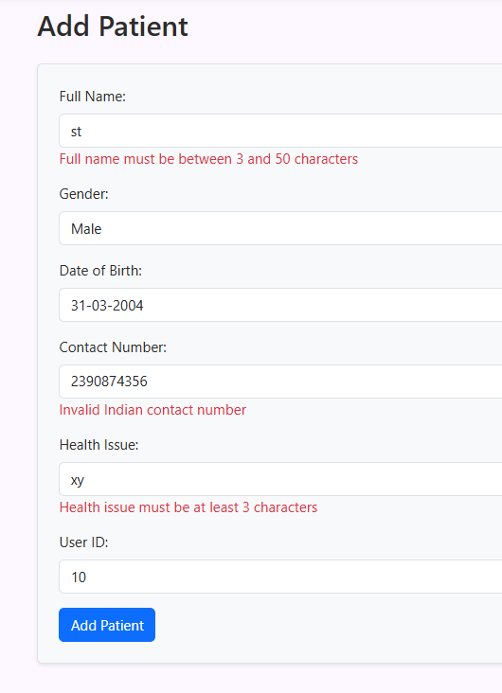

**MOCKITO**

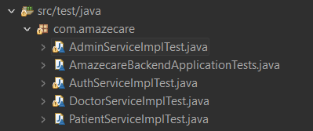

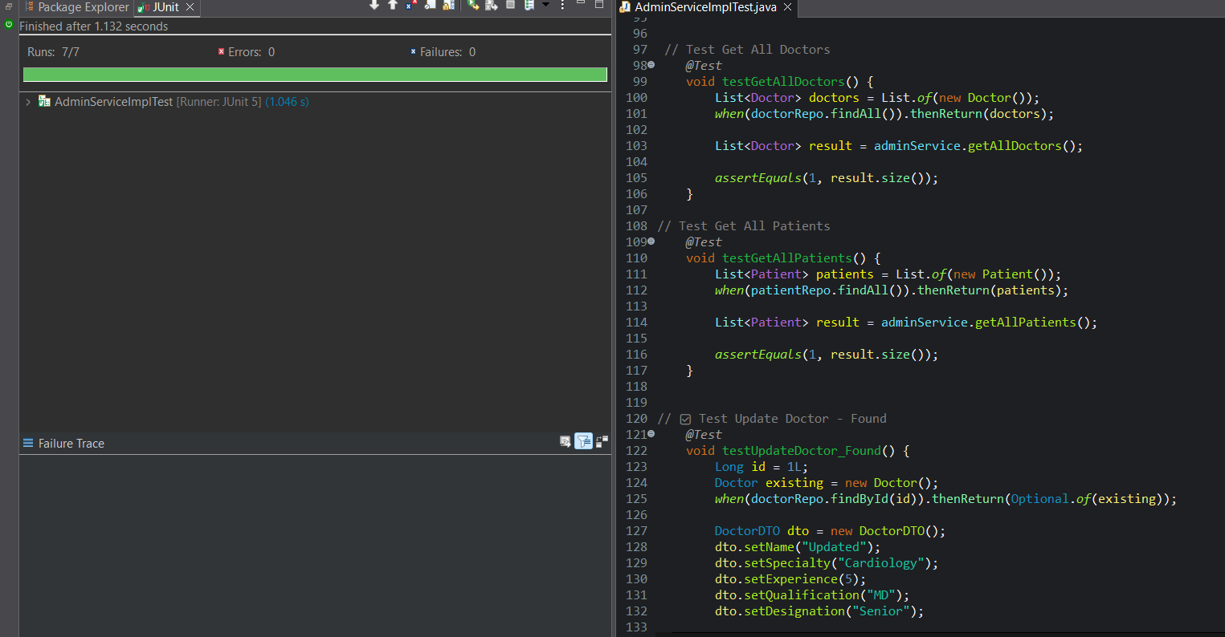

**AuthGuard (Authentication Guard)**

• Prevents **unauthenticated users** from accessing protected routes (like dashboard, appointments).

• Checks if the **JWT token is present and valid** in localStorage.

• Redirects to the **Login page** if the user is not logged in.

• Applied to routes like: canActivate: [AuthGuard]

**RoleGuard (Authorization Guard)**

Ensures **only specific roles** (like ADMIN, DOCTOR, PATIENT) can access certain routes.

Applied to routes with conditions like:

{ path: 'admin/dashboard', component: AdminDashboard, canActivate: [authGuard, roleGuard(['ADMIN'])]},

**FUTURE ENHANCEMENT**

**1) Email and SMS Notifications**

Send appointment confirmations, reminders, and prescription alerts to patients.

**2)** **Medical Report Upload & Download**

Allow patients and doctors to upload or view lab reports, x-rays, or prescriptions.

**3)** **Online Payment Integration**

Enable patients to pay consultation or treatment fees directly via Razorpay/UPI.

**THANK YOU**